CSC ESA
GROUND SEGMENT OPERATIONS FRAMEWORK
OPERATIONS COORDINATION DESK SERVICE

[OMCS] Configuration Tool Architecture and Interfaces Document

Title: | CSC Coordination Desk – [OMCS] Configuration Tool Architecture and Interfaces Document
Abstract: | This document describes the architectural elements and the interfaces of the Configuration Tool
Author: | CD Dev Team | Verified: | Andrea Bolle
 | CSC Coordination Desk Dev Team |  | CSC Coordination Desk Service Manager
Approved: | Andrea Bolle | Authorised: | Roberto Zaccari
 | CSC Coordination Desk Service Manager |  | Product Assurance Manager
Accepted by ESA:
Filename: | CSC Coordination Desk - [OMCS] Configuration Tool Architecture and Interfaces Document i1r1.docx

Document Status Sheet
ISSUE | DATE | AUTHOR | VERIFIED | APPROVED | REASON OF THE MODIFICATION
1.0 | 25/07/2024 | CD Dev Team | A. Bolle | A. Bolle | First Issue
1.1 | 11/11/2024 | CD Dev Team | A. Bolle | A. Bolle | First Issue, first revision

Document Change Record History
No | Change In Issue | Description of Change | Section | Change made by
1 | 1.1 | Added “Processors” releases web page description | 3.4 | CD Dev Team
2 | 1.1 | Added “Processors” web page URL in the external interfaces for End Users | 4.2.2 | CD Dev Team
3 | 1.1 | Added “processors” API URL used to retrieve the Processing Baseline updates from the Configuration Tool | 4.2.5 | CD Dev Team

Table of Content
1 Introduction 6
1.1 Purpose 6
1.2 Structure of the document 6
2 Applicable and Reference Documents, Acronyms 7
2.1 Applicable Documents 7
2.2 Reference Documents 7
2.3 Acronyms and Abbreviations 7
3 Configuration Tool architecture 9
3.1 Overview 9
3.2 The Flask Engine 10
3.3 The backend 11
3.4 The frontend 12
3.4.1 Pages for End Users 12
3.4.2 Pages for the System Administrator 14
4 Configuration Tool Interfaces 15
4.1 Internal Interfaces 15
4.2 External Interfaces 18
4.2.1 Overview 18
4.2.2 External Interfaces for end users 18
4.2.3 External Interface exposed to SentiBoard 19
4.2.4 External Interface for Jira OMCS tickets retrieval 19

Index of Figures
Figure 3-1 The Configuration Tool Default Home page 9
Figure 3-2 The Configuration Tool architecture overview 10
Figure 3-3 The Interfaces web page 12
Figure 3-4 The Services web page 13
Figure 3-5 The Processors web page 13
Figure 3-6 The System Administrator Home page 14
Figure 3-7 The Interfaces Editor web page 14
Figure 4-1 Configuration Tool interfaces with external entities 18

Index of Tables
Table 1 Applicable Documents 7
Table 2 Reference Documents 7
Table 3 Acronyms and abbreviations 8
Table 4 Configuration Tool Internal Interfaces 17
Table 5 Configuration Tool External Interfaces for end users 18

Introduction
The present document is delivered in the context of the OMCS branch of the CSC Coordination Desk Programme.

Purpose
The purpose of the present document is to describe the main architectural element of the Configuration Tool, along with the internal and external interfaces.

Structure of the document
The present document is structured as follows:
- Chapter 1: Introduction – this Chapter;
- Chapter 2: Applicable and Reference documents, Acronyms
- Chapter 3: Configuration Tool Architecture
  - 3.1 Overview
  - 3.2 The Flask Engine
  - 3.3 Configuration Tool backend
  - 3.4 Configuration Tool frontend
- Chapter 4: Configuration Tool Interfaces
  - 4.1 Internal Interfaces
  - 4.2 External Interfaces

Applicable and Reference Documents, Acronyms

Applicable Documents
The following table lists the applicable documents.
Refer. | Title | Code
[AD-IL] | Invitation To Tender for ESA Ground Segment Operations Framework Operations Coordination Desk Service | AO/1-10177/12/I-BG-SC 13.05.2021
[AD-SOW] | Copernicus Space Component - ESA Ground Segment Operations Framework – Coordination Desk Service - STATEMENT OF WORK | ESA-EOPG-EOPGC-SOW-20 Issue 1.0
[AD-DC] | Appendix 2 to ITT – Draft Contract | 13.05.2021
[AD-STC] | Appendix 3 to ITT – Special Conditions of Tender | 13.05.2021
[AD-ADG] | Auxiliary Data Gathering Technical Requirements | ESA-EOPG-EOPGC-RS-17 Issue 1.0
[AD-WEB] | Web Pages Operations Technical Requirement | ESA-EOPG-EOPGC-RS-14 Issue 1.0
[AD-OMCS] | Operations Monitoring and Coordination Service Technical Requirements | ESA-EOPGEOPGC-RS-18 Issue 1.0
[AD-SLA] | SLA and Key Performance Indicators | EOPG-EOPGC-TN-43 Issue 1.0
[AD-SEC] | Coordination Desk Service - Security Requirements Document | ESA-EOPG-EOPGCS-SP-13 Issue 1.0
[AD-CDP] | CSC PDGS/CDS Coordination Desk Procedures | COPE-GSEG-EOPG-PR-14-0035 Issue 2.0
[AD-MNT] | CSC Ground Segment Coordinated Maintenance Procedure, | COPE-PMAN-EOPG-PR-14-0001 Issue 4.0
[AD-CM] | CSC Ground Segment Configuration Management Requirements, | ESA-EOPG-CSCOP-RS-14 Issue 1.0
[AD-AMP] | CSC Ground Segment Anomaly Management Procedure, | GMES-GSEG-EOPG-PR-13-0008 Issue 4.0
[AD-CIDL] | CSC Coordination Desk – Configuration Data Item List | ESA-EOPG-EOPGC-TN-45 Issue 1.0
Table 1 Applicable Documents

Reference Documents
The following table lists the reference documents.
Refer. | Title | Code
[RD-ARCH] | CSC Operations – ESA Framework – Ground Segment Architecture, | ESA-EOPG-EOPGC-TN-7 Issue 1.2
[RD-MICD] | Copernicus Space Component ESA Ground Segment Operations Framework-MasterICD | ESA-EOPG-EOPGC-IF-6 Issue 1.2
[RD-CSDAR] | Copernicus Sentinel Data Access Report https://scihub.copernicus.eu/twiki/pub/SciHubWebPortal/AnnualReport2019/COPESERCO-  RP-20-0570_-_Sentinel_Data_Access_Annual_Report_Y2019_v1.0.pdf
[RD-EUG] | EU green public procurement criteria for data centres, server rooms and cloud services | SWD(2020) 55 final
[RD-NRJ] | Acton, M., Bertoldi, P., Booth, J., Flucker, S., Newcombe, L., Royer, A. and Tozer, R., 2019 Best Practice Guidelines for the EU Code of Conduct on Data Centre Energy Efficiency, European Commission, Ispra, 2018, | JRC114148
[RD-GL] | CSC Sentinel Ground Segment Operations Glossary | ESA-EOPG-EOPGC-TN-13
[RD-STB] | System Technical Budget | ESA-EOPG-EOPGC-TN-09 Issue 1.4
Table 2 Reference Documents

Acronyms and Abbreviations
The following table contains all acronyms and abbreviations used in the current document.
Acronym/Abbreviation | Definition
API | Application Programming Interface
AUX | Auxiliary
AUXIP | Auxiliary Interface (delivery) Point
CADU | Channel Access Data Unit
Cal/Val | Calibration/Validation
CCD | Copernicus Coordination Desk
CFI | Customer Furnished Item
COM | European Commission
CSC | Copernicus Space Component
CVIP | Calibration & Validation Interface (delivery) Point
DD | Data Distribution
DP | Documentation Package
DPA | Dynamic Procurement Approach
E2E | End-to-End
EC | European Commission
ECMWF | European Centre for Medium-Range Weather Forecasts
EDRS | European Data Relay Satellite System
EO | Earth Observation
EOF | ESA Operations Framework
EOP | Earth Observation Programme
ESA | European Space Agency
EU | European Union
EUM | EUMETSAT
FC | Frame Contract
FTP | File Transfer Protocol
GS | Ground Segment
HKTM | Housekeeping Telemetry
ICD | Interface Control Document
IF | Interface
IP | Interface (delivery) Point
IPF | Instrument Processing Facility
ITT | Invitation To Tender
KPI | Key Performance Indicators
LTA | Long Term Archive
MP | Mission Planning
MPIP | Mission Planning Interface (delivery) Point
ODP | On-Demand Processing
ODPRIP | On-Demand Processing Interface (delivery) Point
Table 3 Acronyms and abbreviations

Configuration Tool architecture

Overview
The Configuration Tool is a web application promoted by the European Space Agency in the framework of the Coordination Desk Programme.
This web application is meant to collect the detailed information about the Copernicus Sentinels Ground Segment configuration, the service providers, the interfaces and the processors releases by each production service.
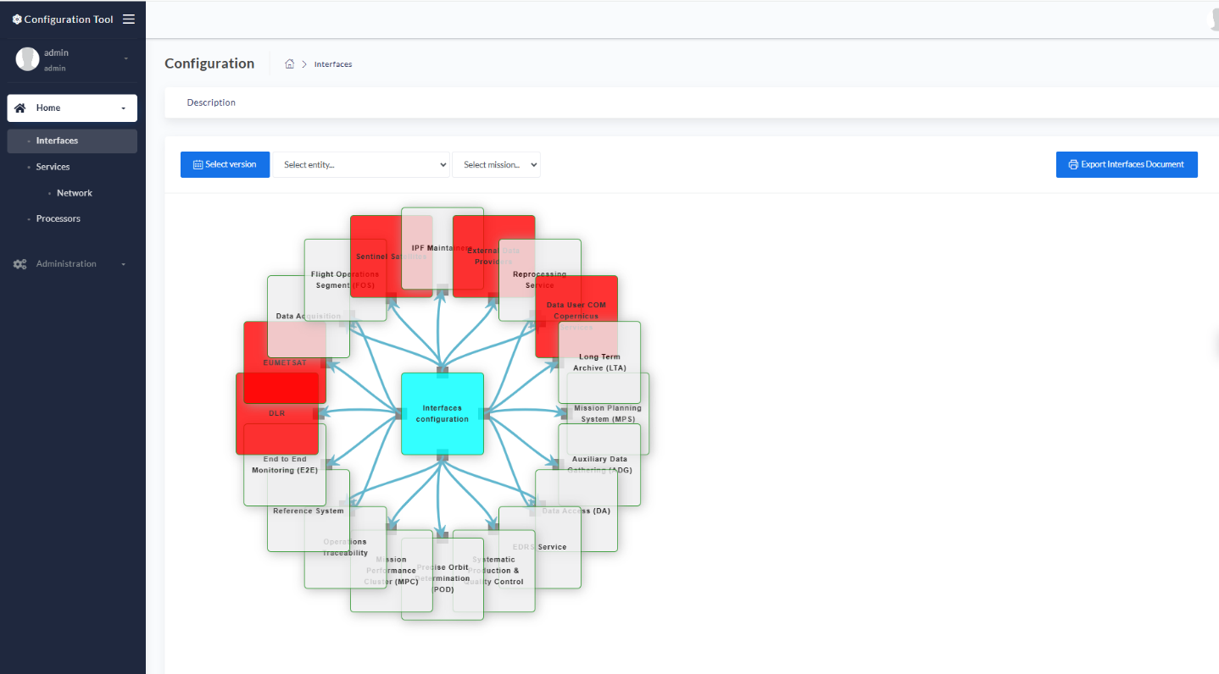
Figure 3-1 The Configuration Tool Default Home page
More in details, the Configuration Tool offers the following views:
- the Interfaces page, with the detailed view of the external and internal interfaces of every component of the Copernicus Ground Segment
- the Services page, meant to collect information about every interface implementation by each Service Provider. This page is enriched also with a Network sub-page, with the IP addresses and the clients whitelisted by each cloud provider
- The Processors’ Releases web page, showing the history of the releases of the processors for all missions, together with the processor’s validity and the reason behind the release
The main source of information is the Jira OMCS: the Configuration Tool is able to connect to that Jira instance and update the Data Model by ingesting the new tickets in “Approved” status, deducing by the custom fields of the tickets all the required information.
The Configuration Tool is deployed as a docker application, with 3 containers, hosting:
- The main web application, consisting of:
  - A frontend, managing the web pages visualization
  - A backend, with the business logic
- The Mongo DB instance, containing the Data Model and the relevant versioning
- The Postgres DB instance, with the information on the configured users
In parallel, two other dockers are deployed, with services applications:
- Mongo Express, for the administrative functions on the Mongo DB instance
- PGAdmin, for the administrative functions on the Postgres DB instance
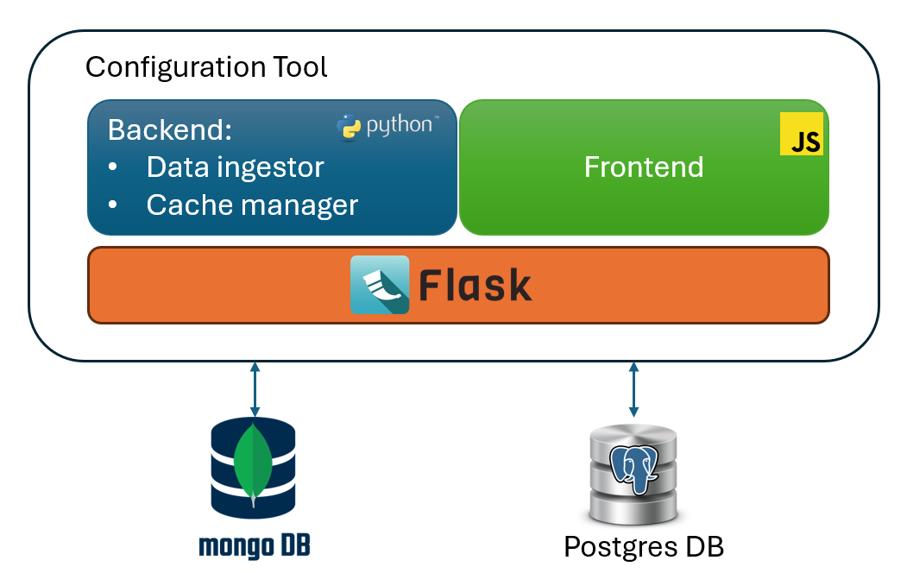
Figure 3-2 The Configuration Tool architecture overview
The Configuration Tool workflow is the following:
- At startup, or/and every hour, an ingestion job is thrown, aiming to collect data through queries addressed to the Jira OMCS instance
- Ingested and aggregated data are stored in the Mongo DB, containing the Data Model (Postgres DB is used for the storage of local users only)
- Upon connection by the End Users, the updated model is displayed in the relevant page.

The Flask Engine
Flask is a micro web framework written in Python. It is classified as a microframework because it does not require additional tools or libraries. It has no database abstraction layer, form validation, or any other components where pre-existing third-party libraries provide common functions. However, Flask supports extensions that can add application features as if they were implemented in Flask itself. Extensions exist for object-relational mappers, form validation, upload handling, various open authentication technologies and several common framework related tools.
Applications that use the Flask framework include Pinterest and LinkedIn.
Flask has many configuration values, with sensible defaults, and a few conventions when getting started. By convention, templates and static files are stored in subdirectories within the application’s Python source tree, with the names’ templates and static respectively. While this can be changed, you usually don’t have to, especially when getting started.
The microframework Flask is part of the Pallets Projects (formerly Pocoo), and based on several others of them, all under a BSD license:
- Werkzeug (German for "tool") is a utility library for the Python programming language for Web Server Gateway Interface (WSGI) applications. Werkzeug can instantiate objects for request, response, and utility functions. It can be used as the basis for a custom software framework and supports Python 2.7 and 3.5 and later.[15][16]
- Jinja, also by Ronacher, is a template engine for the Python programming language. Similar to the Django web framework, it handles templates in a sandbox.
- MarkupSafe is a string handling library for the Python programming language. The eponymous MarkupSafe type extends the Python string type and marks its contents as "safe"; combining MarkupSafe with regular strings automatically escapes the unmarked strings, while avoiding double escaping of already marked strings.
- ItsDangerous is a safe data serialization library for the Python programming language. It is used to store the session of a Flask application in a cookie without allowing users to tamper with the session contents.
Flask is based on two main concepts, namely “views” and “Blueprints”. Below, a description of these concepts is reported.
A view function is the code you write to respond to requests to your application. Flask uses patterns to match the incoming request URL to the view that should handle it. The view returns data that Flask turns into an outgoing response. Flask can also go the other direction and generate a URL to a view based on its name and arguments.
A Blueprint is a way to organize a group of related views and other code. Rather than registering views and other code directly with an application, they are registered with a blueprint. Then the blueprint is registered with the application when it is available in the factory function.
An application with resources protected by authentication will have at least two blueprints, one for authentication functions and one for the core-business functions. The code for each blueprint will go in a separate module. Since the blog needs to know about authentication, you’ll write the authentication one first.

The backend
The backend is represented by the Flask light-weight server, written in Python (v3.10 is used for the present tool). It consists of two main modules:
- The jira ticket ingestor, retrieving the raw data from the Jira OMCS instance on Cloud
- The Data Model manager, aggregating the data and saving them into the Mongo database
Both modules, represented by python code packages, contain dedicated files meant to manage specific data types.
The Data Model is articulated into the following instances:
- The Interfaces configuration, representing the interfaces among the different components of the Copernicus Ground Segment. This Data Model is intended to provide the tables and the pictures for the CSC Ground Segment Master ICD
- The Services configuration, meant to collect the information about every Service Provider, such as the hosting Cloud provider, the domain / URL, etc…together with some additional info on the interface implementations. This Data Model is intended to provide the tables and the pictures for the CSC ESA Operational Configuration document
- The Processors configuration, meant to collect the information on every processor’ s release, the new implementation or the bug fixing, and the impacted Processing Baseline or IPF.
In the future, a new Data Model instance will be implemented, meant to provide the tables and the pictures for the Copernicus Ground Segment Sentinels Data Flow Configuration.

The frontend
The frontend is represented by a number of HTML pages, compatible with version 5.0, managed by a set of corresponding Javascript files, importing the following main libraries:
- Jquery 13.1
- Bootstrap 4.0
Web pages can be grouped as follows:
- Pages for End Users: meant to be displayed by every user having valid credentials. End Users are ESA personnel and Technical Officers, Coordination Desk staff
- Pages reserved to the System Administrator: permitting to perform manual refinement on the Data Model
Below, an overview of the web application pages is provided.

Pages for End Users
The Interfaces page reports a detailed view of the external and internal interfaces of every component of the Copernicus Ground Segment. Users can filter the relevant interfaces by:
- Service, using the dedicated dropdown menu
- Satellite, using the dedicated dropdown menu
By choosing a Service, the interface diagram will be centred around that service, showing the in/out connections. By clicking on an interface name, some information about the selected interface will be displayed. Satellite and Service filters work in parallel: users can select a Service and then narrow the displayed connections by selecting the mission of interest.
This view offers the capability of loading past committed versions of the interface diagrams, by clicking on button located at the left-hand side of the header bar.
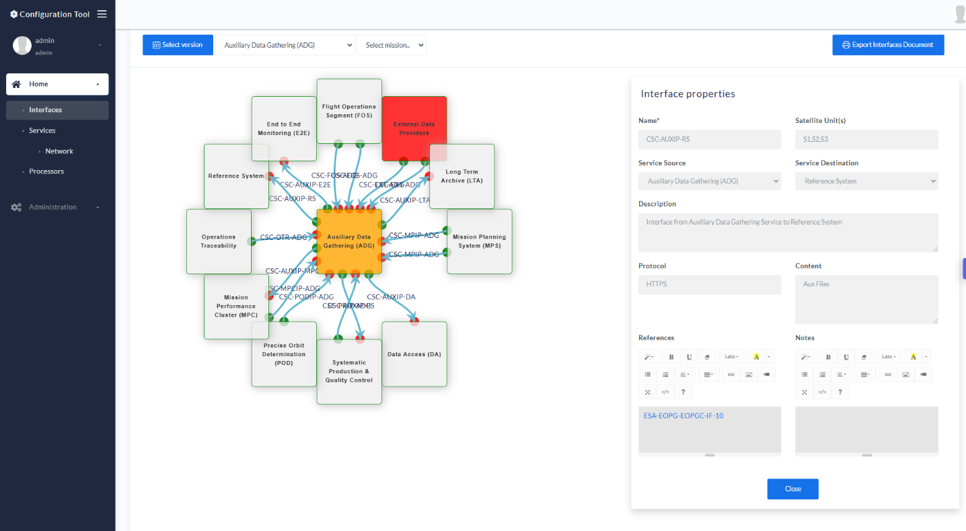
Figure 3-3 The Interfaces web page
The Services page is meant to collect information about every interface implementation by each Service Provider. In the Services page, operational I/Fs are displayed in green; blue is used to mark I/Fs that will be implemented in the future. Even in this case, it is possible to filter both the Services and the relevant connection by satellite.
The Services page is also enriched with a Network sub-page, with the IP addresses and the clients whitelisted by each cloud provider.
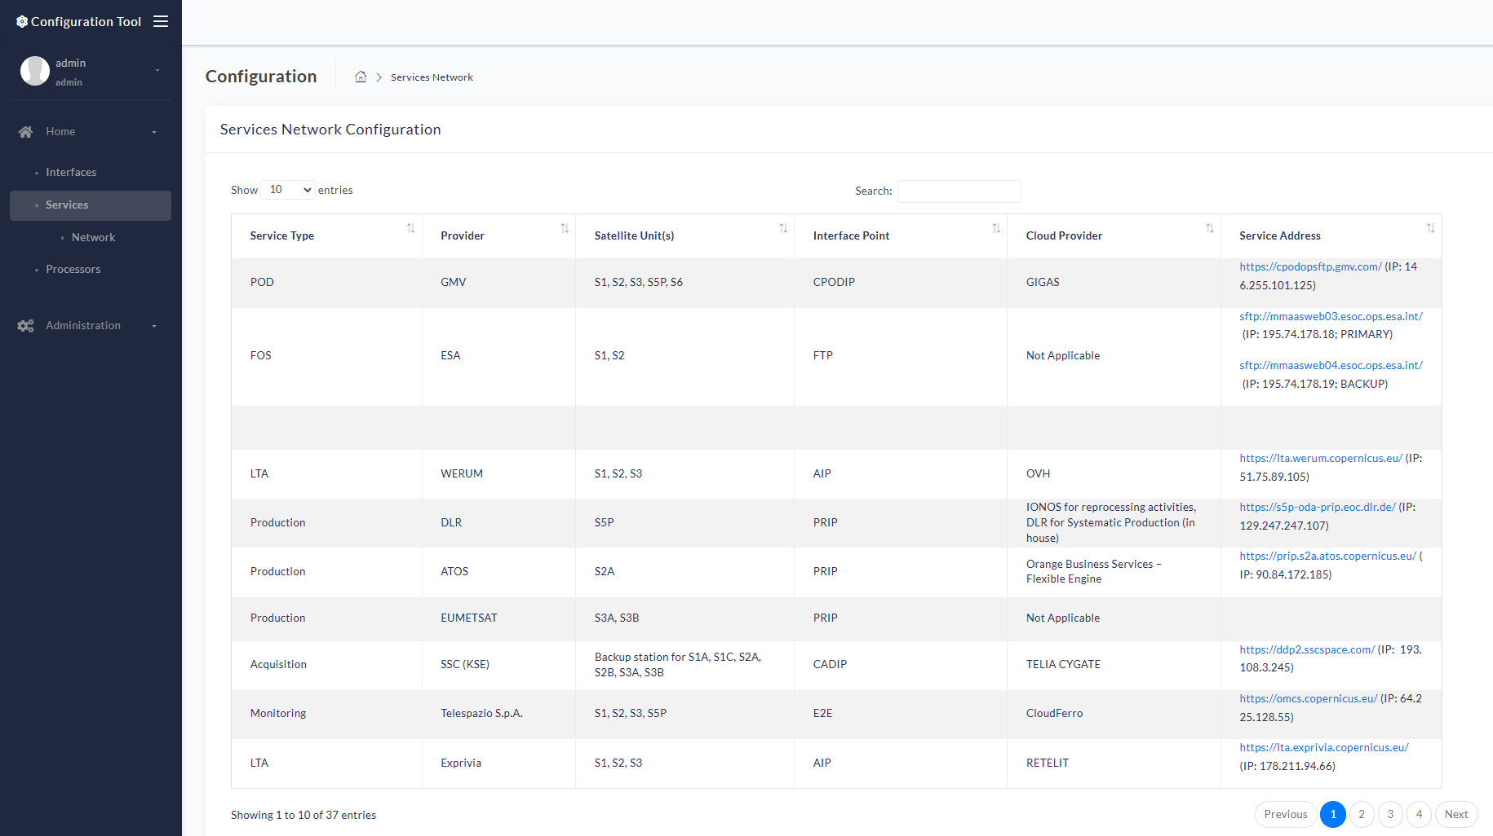
Figure 3-4 The Services web page
The Processors’ Releases web page, showing the history of the releases of the processors for all missions, together with the processor’s validity and the release notes with the implementations behind the release.
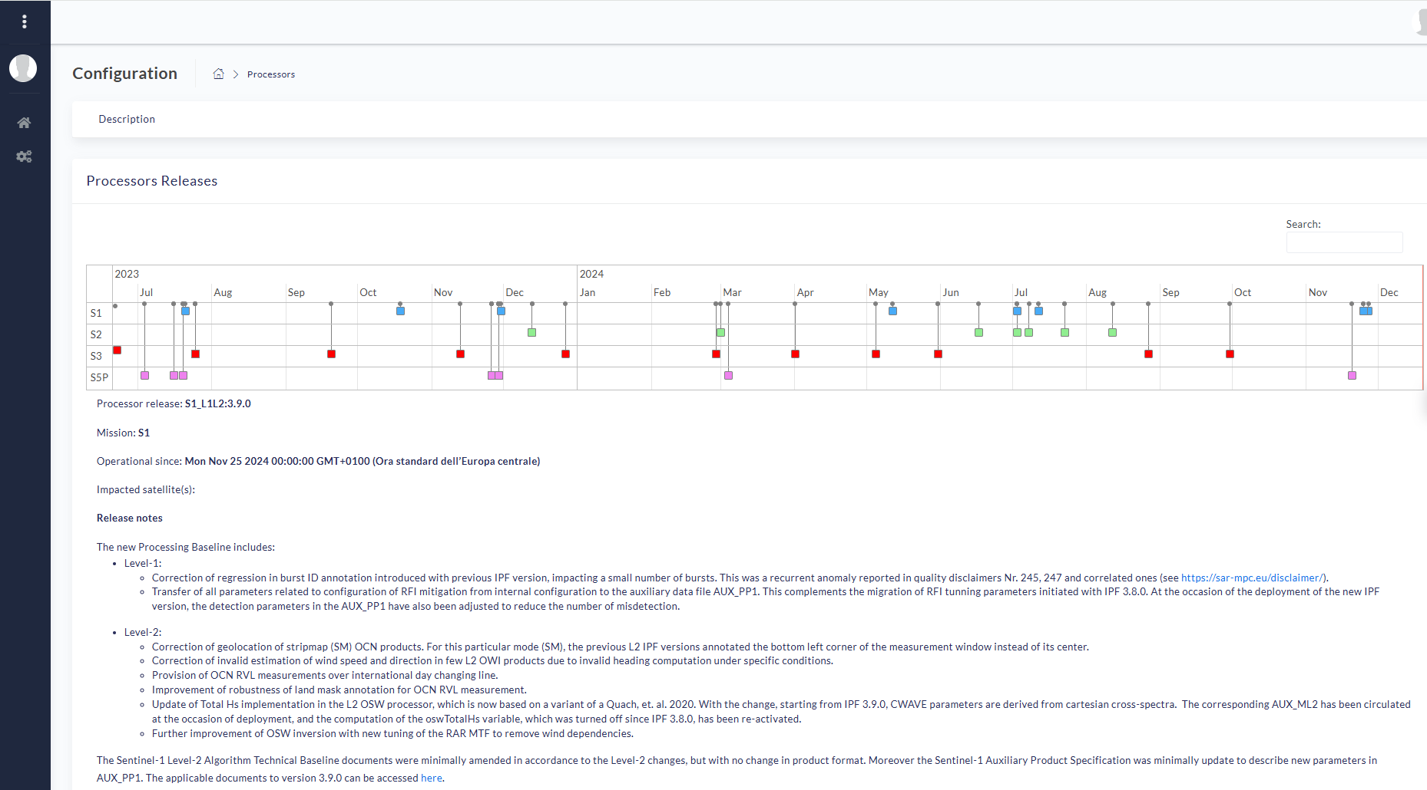
Figure 3-5 The Processors web page

Pages for the System Administrator
If logged as a System Administrator, additional pages will be displayed.
The System Administration Home page allows the deletion or the opening of any of the available Data Model for manual editing.
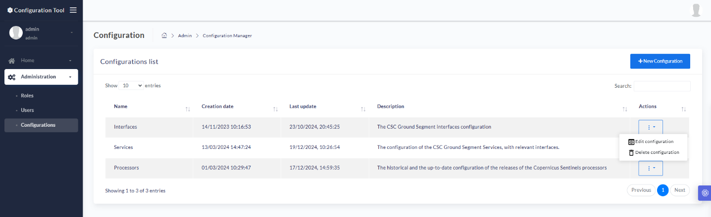
Figure 3-6 The System Administrator Home page
The administration pages are basically implemented as editable tables, permitting a manual tuning of each property of the Data Model instance. Below, as an example, the look and feel of the Interfaces Editor web page is provided.
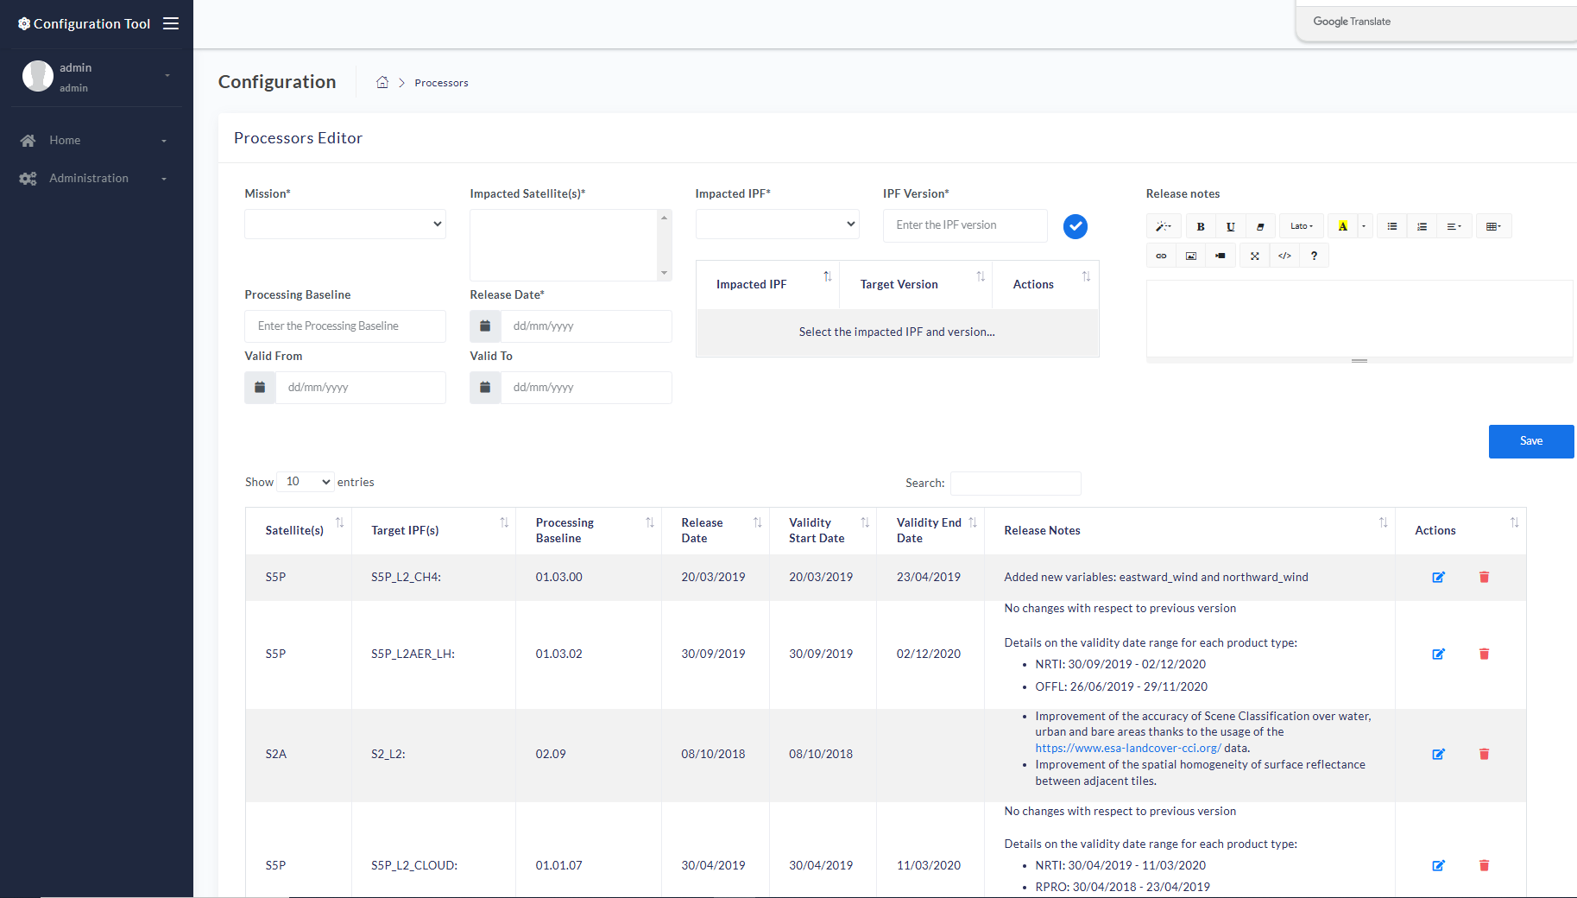
Figure 3-7 The Interfaces Editor web page

Configuration Tool Interfaces

Internal Interfaces
This section reports the internal interfaces of the Configuration Tool, i.e. the description of the REST APIs used to edit the different Data Model instances and the Users configurations.
API URL | Method | Description
rest/api/interfaces/<config_id> | GET | Returns the selected “Interfaces” configuration
rest/api/interfaces/<config_id> | PUT | Update the selected “Interfaces” configuration
rest/api/interfaces/<config_id> | DELETE | Delete the selected “Interfaces” configuration
rest/api/interfaces/entity | POST | Add a new Entity in the “Interfaces” configuration diagram
rest/api/interfaces/entity | PUT | Update an existing Entity in the “Interfaces” configuration diagram
rest/api/interfaces/entity | DELETE | Delete an existing Entity from the “Interfaces” configuration diagram
rest/api/interfaces/interface | POST | Add a new interface in the “Interfaces” configuration diagram
rest/api/interfaces/interface | PUT | Update an interface in the “Interfaces” configuration diagram
rest/api/interfaces/interface | DELETE | Delete an interface from the “Interfaces” configuration diagram
rest/api/interfaces/commit/<config_id> | GET | Retrieve all commits relevant to the specified “Interfaces” configuration
rest/api/interfaces/commit/<config_id>/<n_ver> | GET | Retrieve the commit relevant to the specified “Interfaces” configuration
rest/api/interfaces/commit/<config_id>/<tag> | GET | Retrieve the tag relevant to the specified “Interfaces” configuration
rest/api/interfaces/commit | POST | Commit the specified “Interfaces” configuration
rest/api/interfaces/document/upload/<config_id>/<image_id> | POST | Save in the backend a picture representing the “Interfaces” configuration with focus on the specified Entity
rest/api/interfaces/document/<config_id> | GET | Download the CSC Master ICD document according to the specified “Interfaces” configuration
rest/api/services/<config_id> | GET | Returns the selected “Services” configuration
rest/api/services | POST | Add a new Service Provider in the “Services” configuration
rest/api/services | PUT | Update an existing Service Provider in the “Services” configuration
rest/api/services | DELETE | Delete an existing Service Provider in the “Services” configuration
rest/api/services/interfaces | POST | Add a new interface in the “Services” configuration diagram
rest/api/services/interfaces | PUT | Update an interface in the “Services” configuration diagram
rest/api/services/interfaces | DELETE | Delete an interface from the “Services” configuration diagram
rest/api/services/commit/<config_id> | GET | Retrieve all commits relevant to the specified “Services” configuration
rest/api/services/commit/<config_id>/<n_ver> | GET | Retrieve the commit relevant to the specified “Services” configuration
rest/api/services/commit/<config_id>/<tag> | GET | Retrieve the tag relevant to the specified “Services” configuration
rest/api/services/commit | POST | Commit the specified “Services” configuration
rest/api/services/document/upload/<config_id>/<image_id> | POST | Save in the backend a picture representing the “Services” configuration with focus on the specified satellite unit
rest/api/services/document/<config_id> | GET | Download the CSC ESA Operational Configuration document according to the specified “Services” configuration
rest/api/processors-releases/<config_id> | GET | Returns the selected “Processors Releases” configuration
rest/api/processors-releases | POST | Add a new Processor Release to the specified configuration
rest/api/processors-releases | PUT | Update an existing Processor Release to the specified configuration
rest/api/processors-releases | DELETE | Delete an existing Processor Release to the specified configuration
rest/auth/user | GET | Retrieve the information about the logged user
rest/auth/users | GET | Return the list of configured users
rest/auth/users | POST | Add a new user
rest/auth/users | PUT | Edit an existing user
rest/auth/users | DELETE | Delete and existing user
Table 4 Configuration Tool Internal Interfaces

External Interfaces

Overview
The Configuration Tool external interfaces belong to three distinct families:
- The URLs of the web pages exposed to the end users
- The REST API exposed to the Sentiboard for sharing the anomalies opened within a specified time range
- The queries addressed to the JIRA OMCS to retrieve the Jira tickets
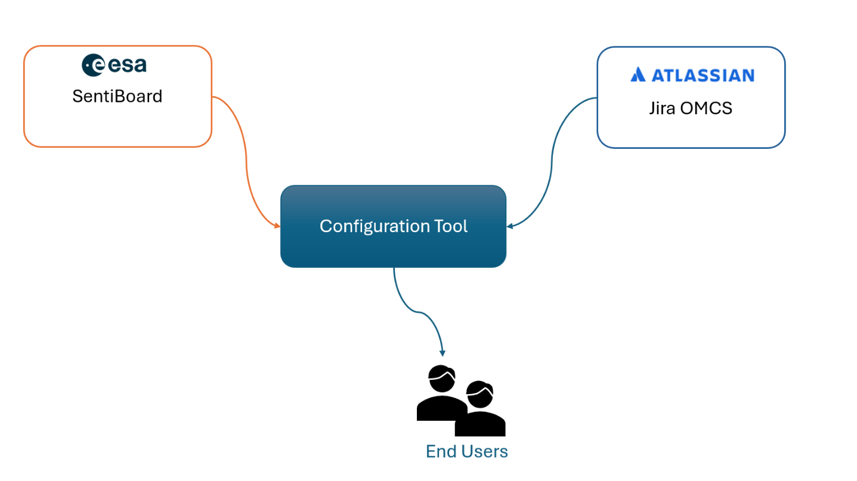
Figure 4-1 Configuration Tool interfaces with external entities
Below, a dedicated description for the three groups of interfaces is provided.

External Interfaces for end users
This section reports the URLs exposed to the End Users for web pages navigation (administrative pages are omitted).
Web Page | URL
Root URL | https://configuration.copernicus.eu/
Interfaces | https://configuration.copernicus.eu/interfaces-viewer.html
Services | https://configuration.copernicus.eu/services-viewer.html
Services Network | https://configuration.copernicus.eu/services-network-config-viewer.html
Processors Releases | https://configuration.copernicus.eu/processors-viewer.html
Table 5 Configuration Tool External Interfaces for end users

External Interface exposed to SentiBoard
This section describes the interface exposed to SentiBoard used for sharing the processors releases. In fact, SentiBoard connects to the to retrieve the processors releases displayed in the Processors web page. Below, the details about this interface are reported:
- Configuration Tool endpoint:
https://configuration.copernicus.eu/rest/api/baseline/processors-releases
- Method: GET
- Returned output: JSON array with the representation of the processors’ releases, each one including the following fields:
  - Impacted mission and satellite unit
  - Target IPF
  - Processing Baseline
  - Release Date
  - Validity Start / Stop time
  - Release Note

External Interface for Jira OMCS tickets retrieval
To retrieve tickets from Jira OMCS, the following JQL query is executed:
project=SOA AND issuetype=’IPF deployment AND status=APPROVED AND create >= -40w order by ‘created’ DESC”

